**Jenkins task-2**

1. **Configure 2 slave machines in Jenkins master.**

**First to create instances Jenkins-master,slave-01 and slave -02**

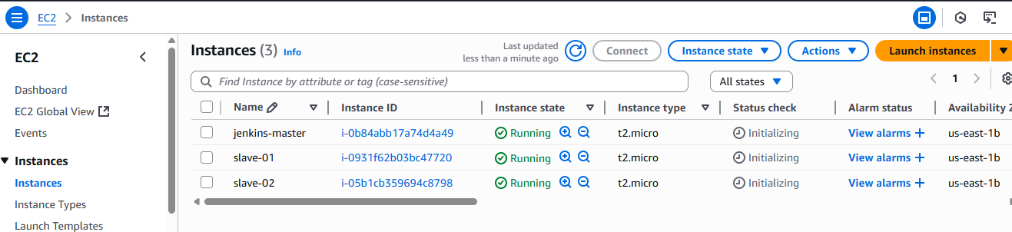

**Step-1 :** Create an ec2 –slave-01

Login to slave machine..

switch to **root user**

**dnf install -y java-17-amazon-corretto**

Create **ssh-keygen**

**cat id_rsa.pub > authorized_keys**

**chmod 700 authorized_keys**

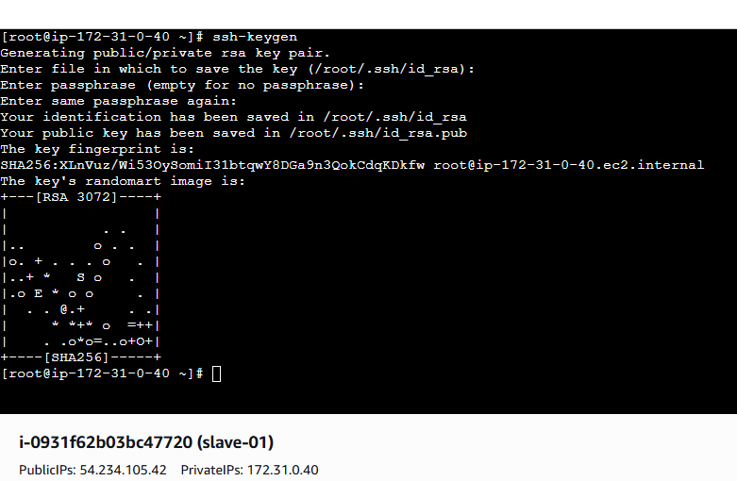

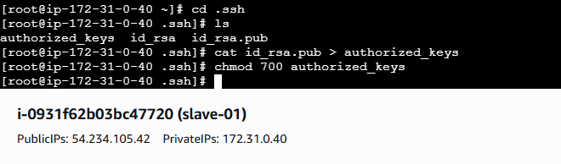

**Login to master machine**

**switch to root user**.

**mkdir -p /var/lib/jenkins/.ssh**

**cd /var/lib/jenkins/.ssh**

**ssh-keyscan -H SLAVE-NODE-IP-OR-HOSTNAME >>/var/lib/jenkins/.ssh/known_hosts**

# **ssh-keyscan -H 54.234.105.42 >> /var/lib/jenkins/.ssh/known_hosts**

**chown jenkins:jenkins known_hosts**

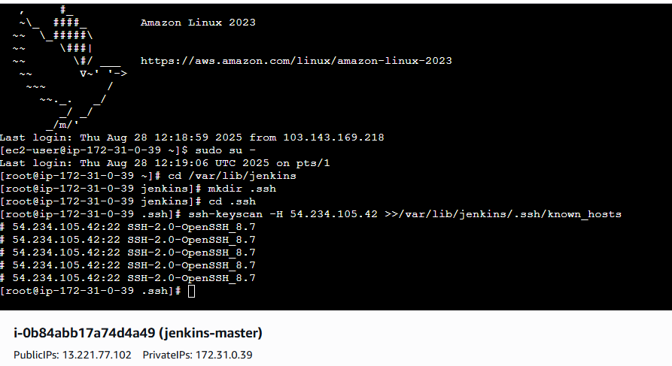

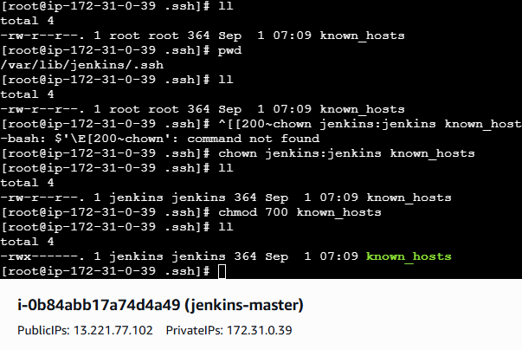

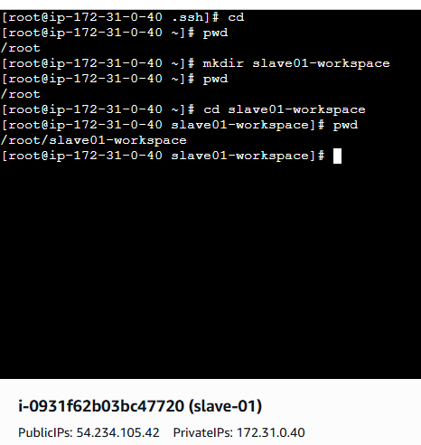

**Steps on Jenkins GUI**

Go to **Manage Jenkins → Manage Nodes and Clouds → New Node**

Give it a name (e.g., **slave-1)**

Select **Permanent Agent**

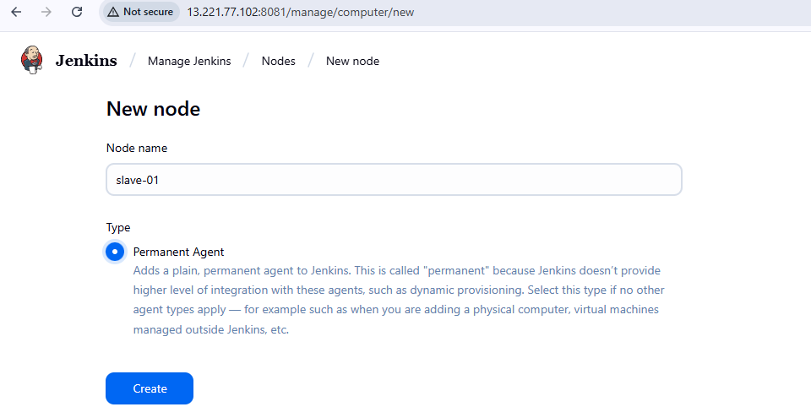

**To Configure Node**

* + **Remote root directory**: /home/ec2-user (or another working dir on slave)
  + **Labels**: (optional, e.g., Java)
  + **Launch method**: *Launch agent via SSH*
  + **Host**: *Public IP of Slave*

**Add Credentials**

* + Kind: *SSH Username with private key*
  + Username: ec2-user
  + Private key: Paste your .pem key (from AWS)
  + Save

**Save & Test Connection**

* + Jenkins master should now connect to the slave machine via SSH.

If successful, the node status will show as **online**

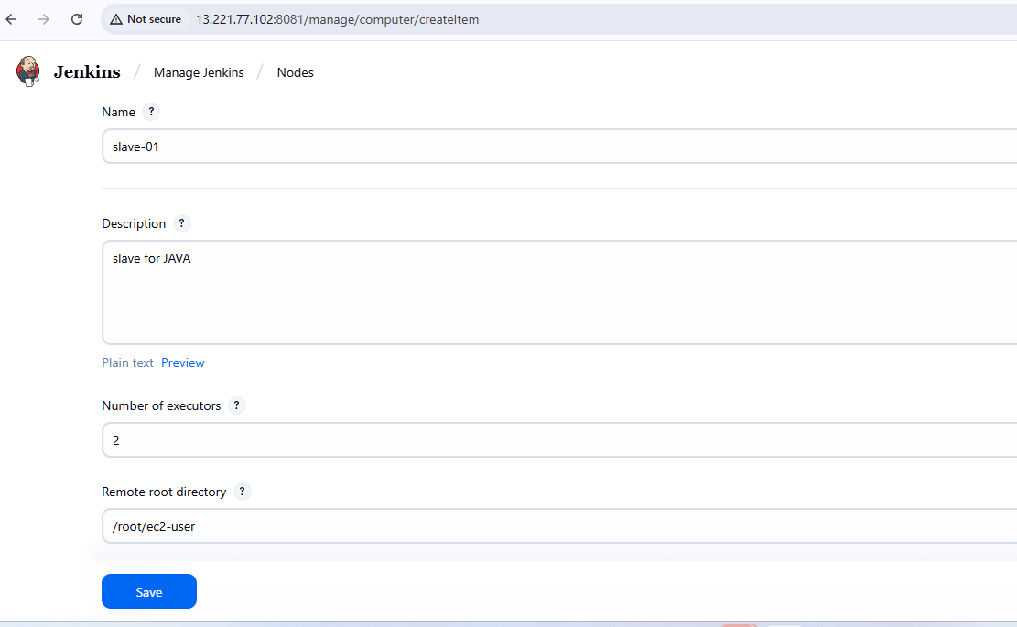

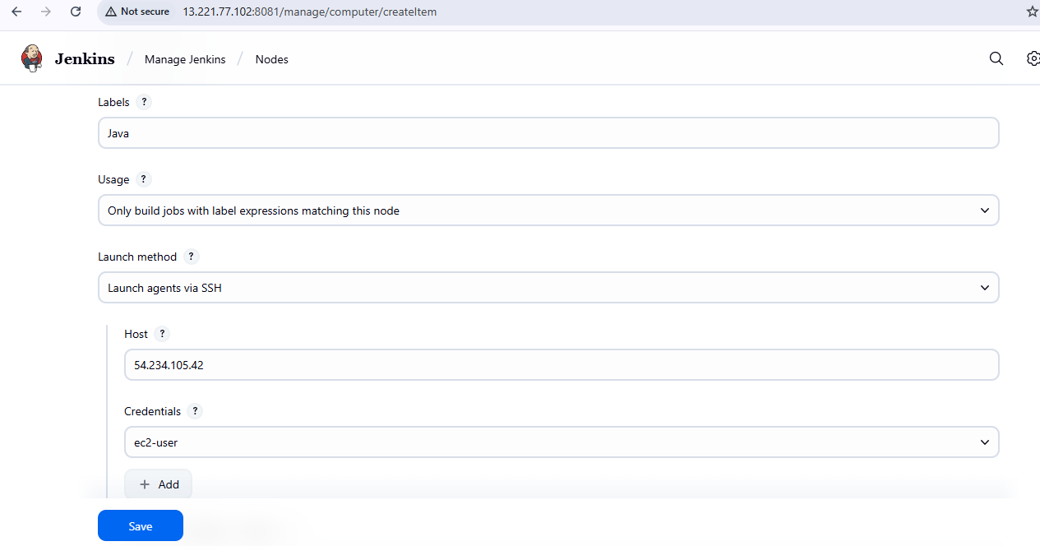

**Save & Test Connection**

* + Jenkins master should now connect to the slave machine via SSH.

If successful, the node status will show as **online**

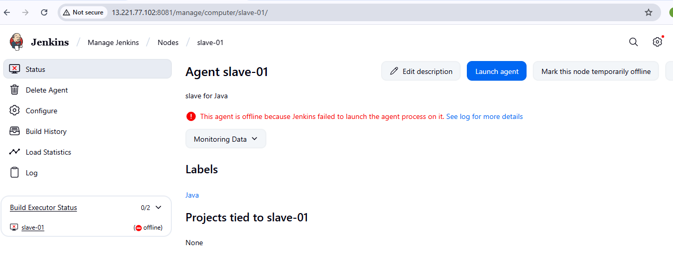

It shows like this to exit from root user

In **pwd** the path is **/home/ec2-use**r add this **path Remote root directory** of **created node slave-01**

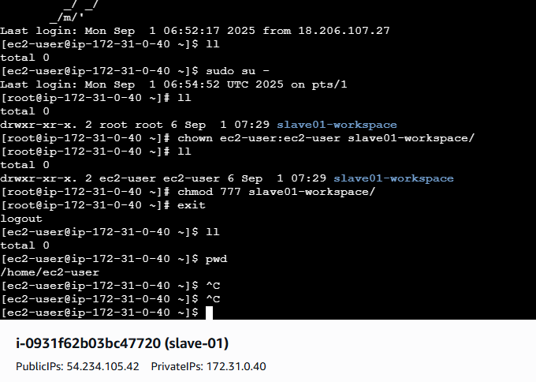

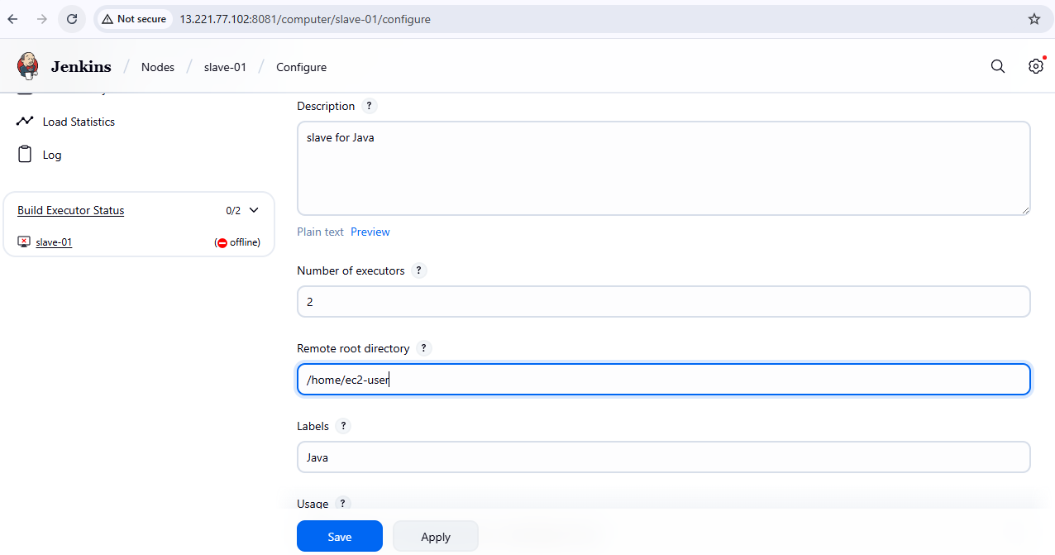

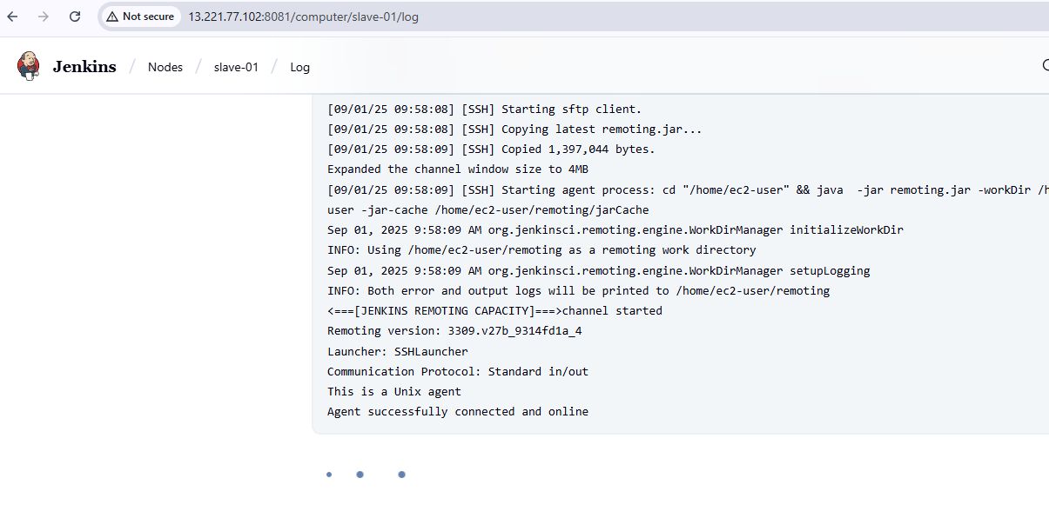

To create a **job(slave-01)** and **configure** it in **Java Label**

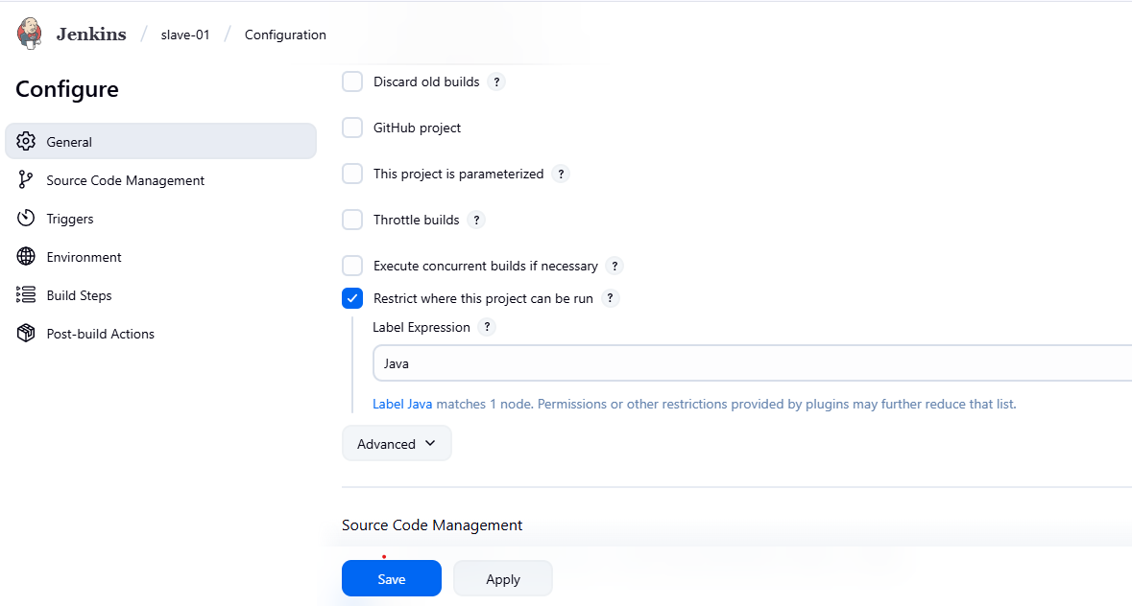

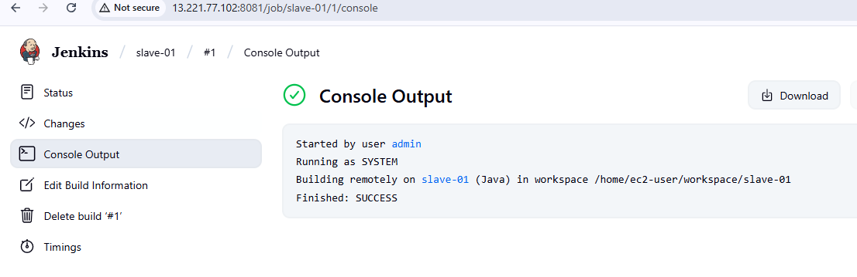

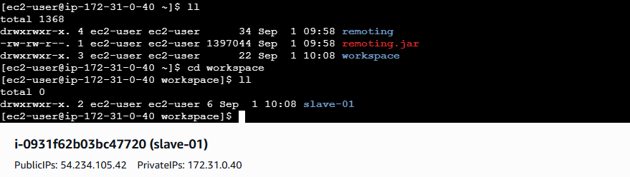

### **Create the node in Jenkins GUI**

1. **Manage Jenkins → Nodes → New Node**
2. **Name: slave2 → Type: Permanent Agent**
3. **Remote root directory: /home/ec2-user**
4. **This path is taken from slave machine**
5. **Slave ec2 → cat /etc/passwd**
6. **chown ec2-user:ec2-user slave02-workspace**
7. **chmod 777 slave02-workspace**
8. **Labels: slave2 java (as you like)**
9. **Usage: “Only build jobs with label expressions” (optional)**
10. **Launch method: Launch agents via SSH**
    * **Host: <NEW_AGENT_IP_OR_DNS>**
    * **Credentials: create/select “SSH Username with private key”**
      + **Username: ec2-user**
      + **Private key: paste content of /var/lib/jenkins/.ssh/id_rsa from the master**
    * **Host Key Verification Strategy: Known hosts file (recommended)**

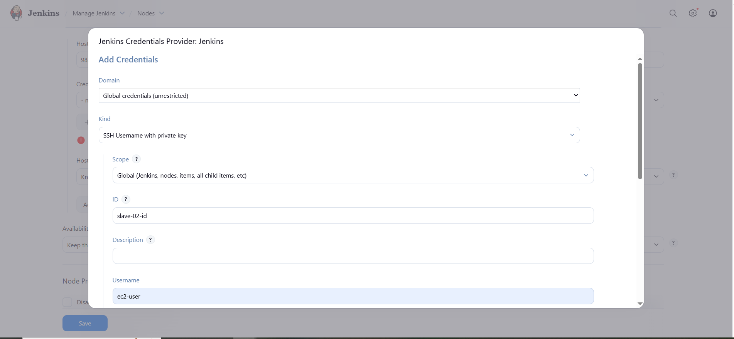

1. **Save → Jenkins should connect and show Online.**

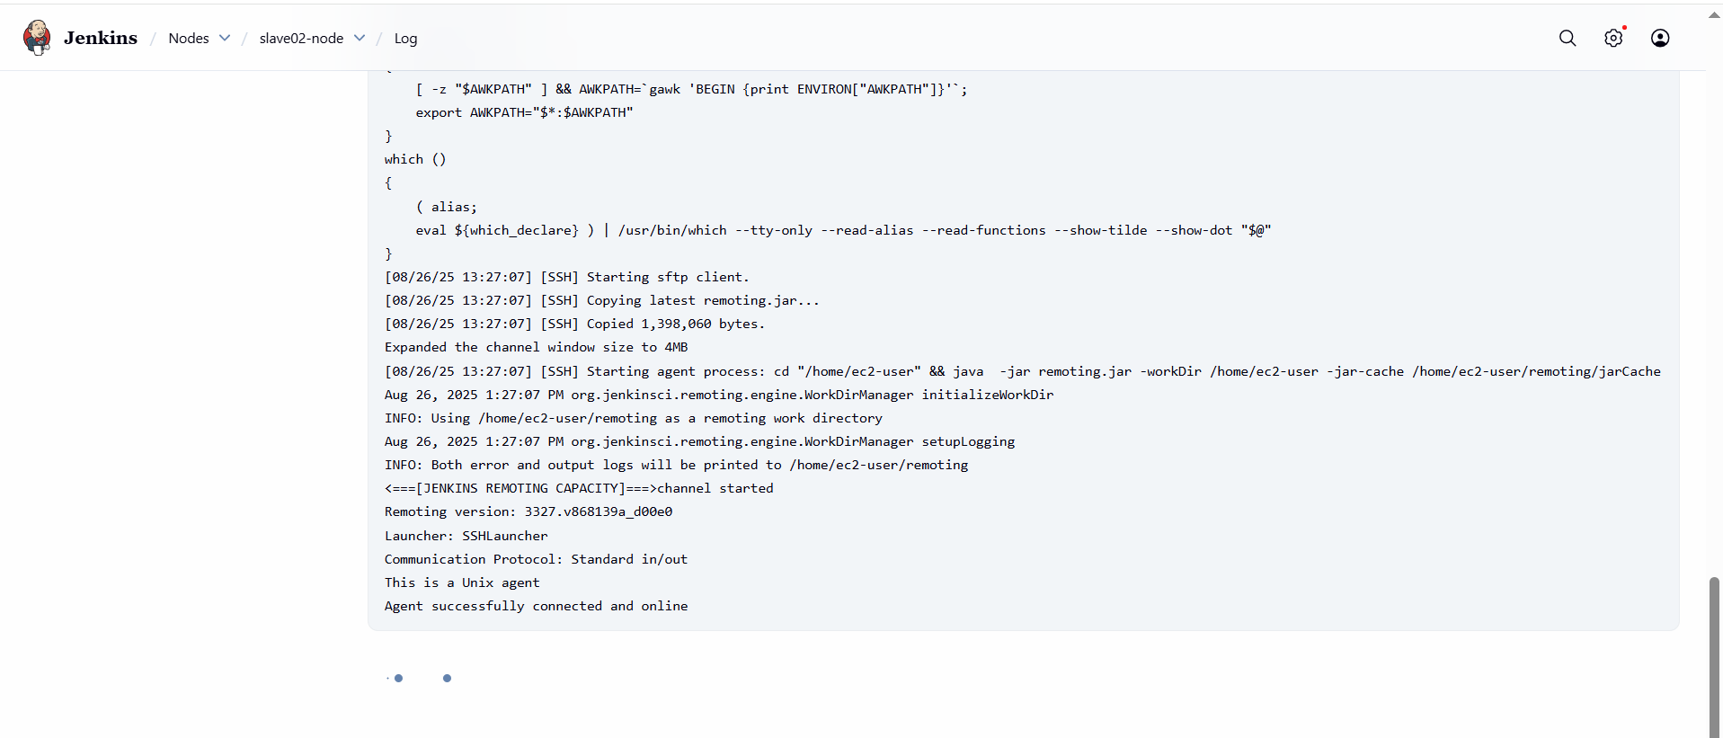

**Now you can see one master node and two slave nodes available.**

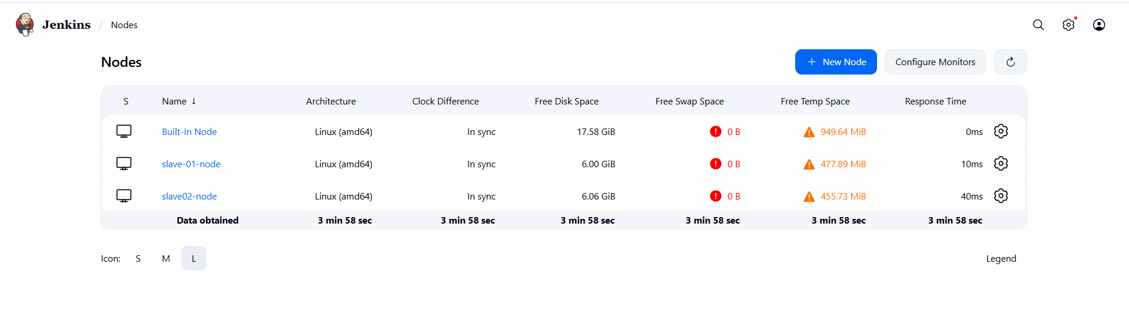

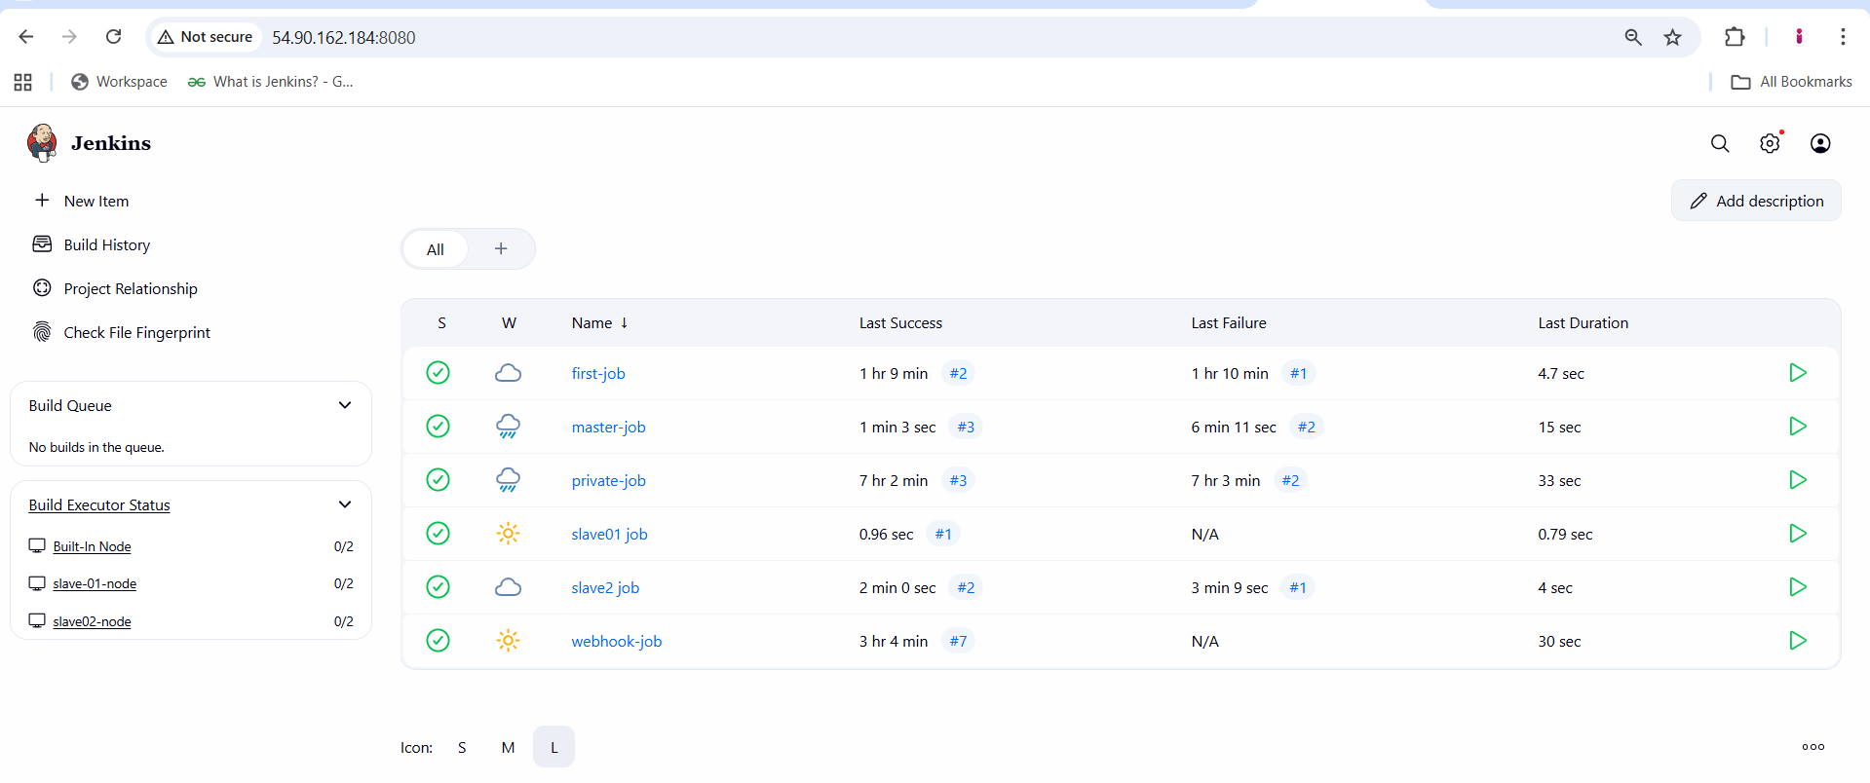

**2) Configure webhooks to Jenkins job**

First we need to copy **Jenkins url** 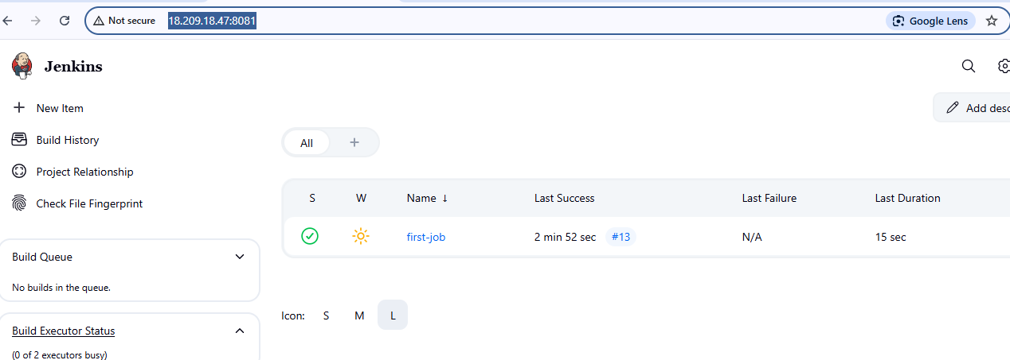

Go to **github repo → settings → webhooks → payload URL ([http://18.209.18.47:8081/github-webhook/](http://54.90.162.184:8080/github-webhook/)) → content type (application/json) →** select **send me everything →**click **Add webhook**

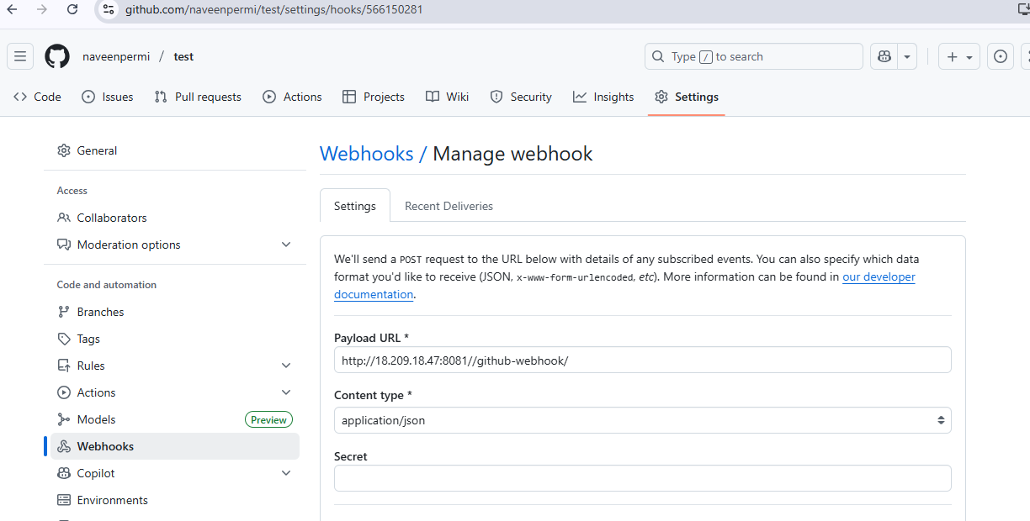

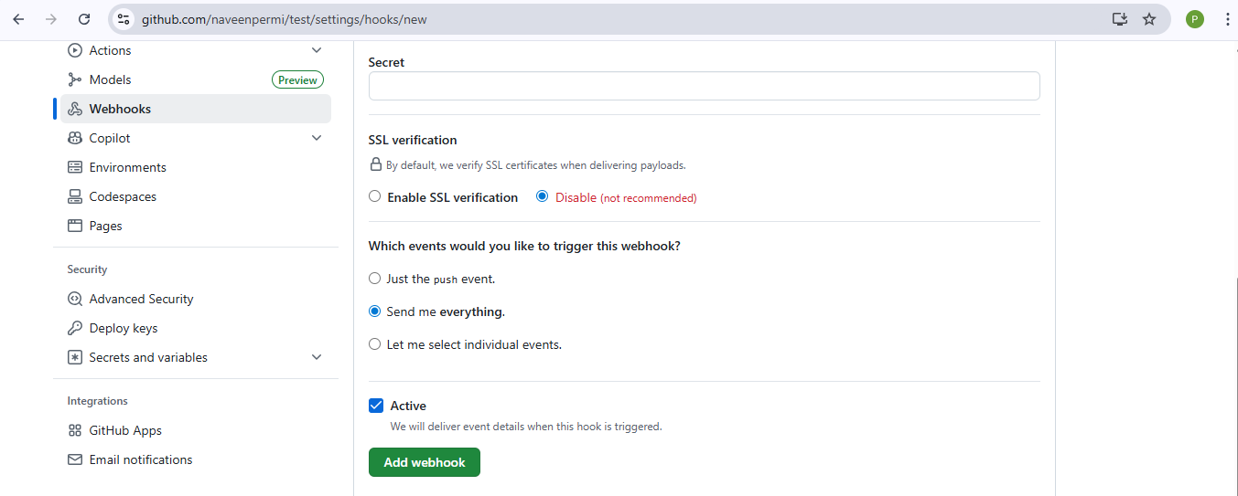

**Go to Jenkins →** select your job(**first-job) →** add **github u**r**l** in **git repository**

**→** select **Poll SCM** in **Triggers →** To keep **sleep 60** in **Execute shell →** click **save**

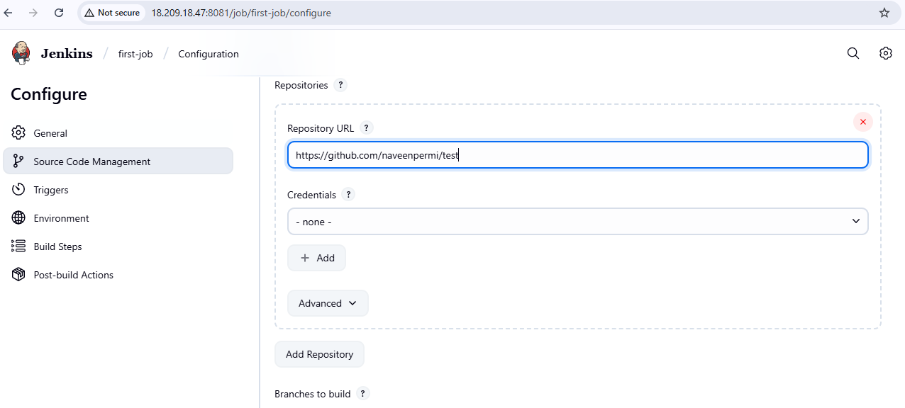

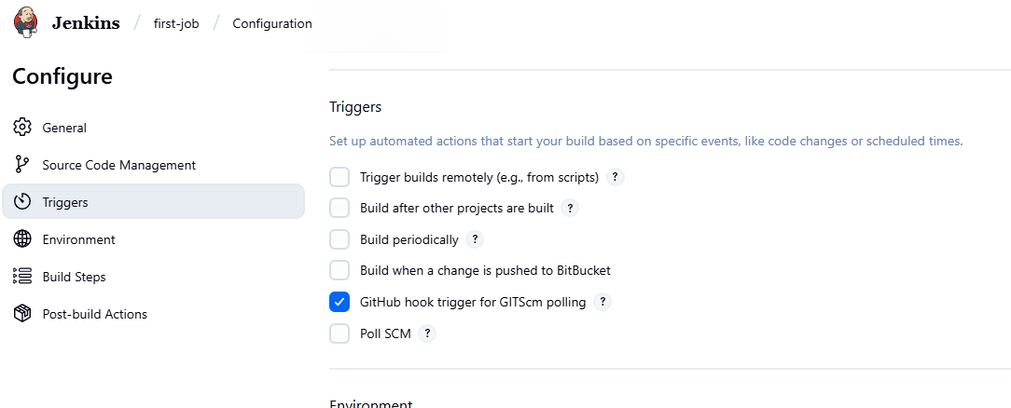

Now go to your **github repo** and **change or edit or update** the any file of the **source code and commit**

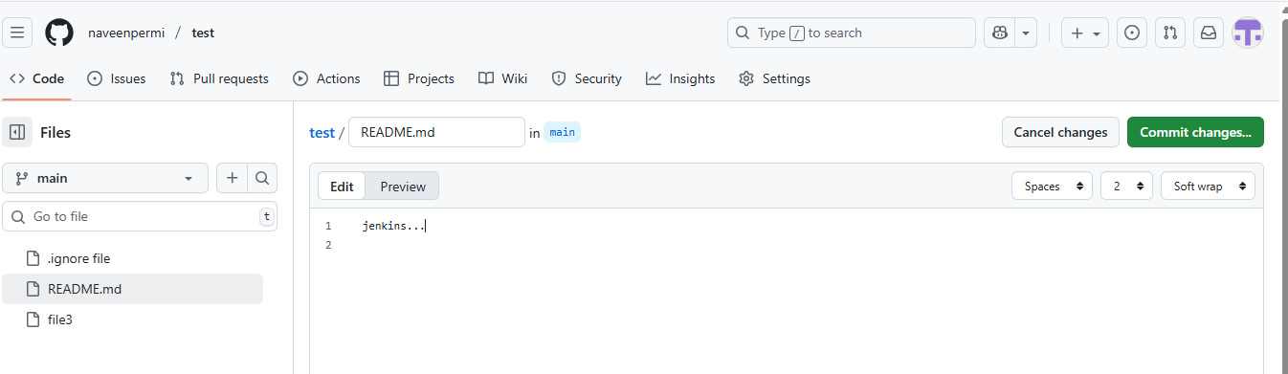

Then we see the **automatically job triggers** in **Jenkins**

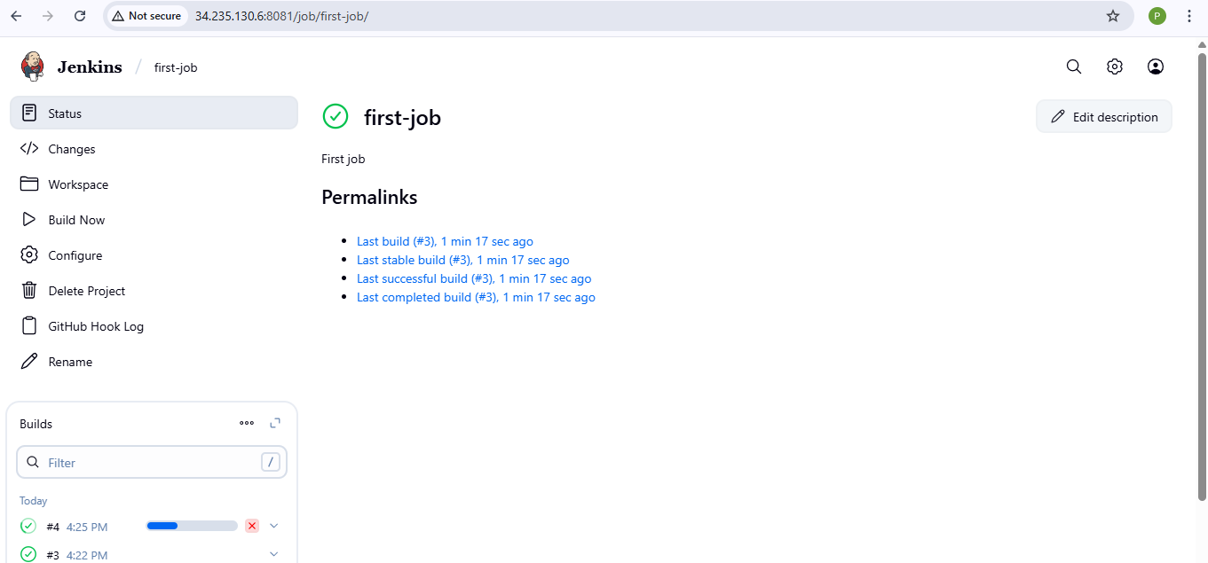

**3) Configure poll scm and build periodical options in Jenkins job.**

**i)To configure poll scm in Jenkins job.**

**Go to Jenkins →** select your job(**first-job) →** add **github u**r**l** in **git repository**

**→** select in **Triggers →** To keep **sleep 15** in **Execute shell →** click **save**



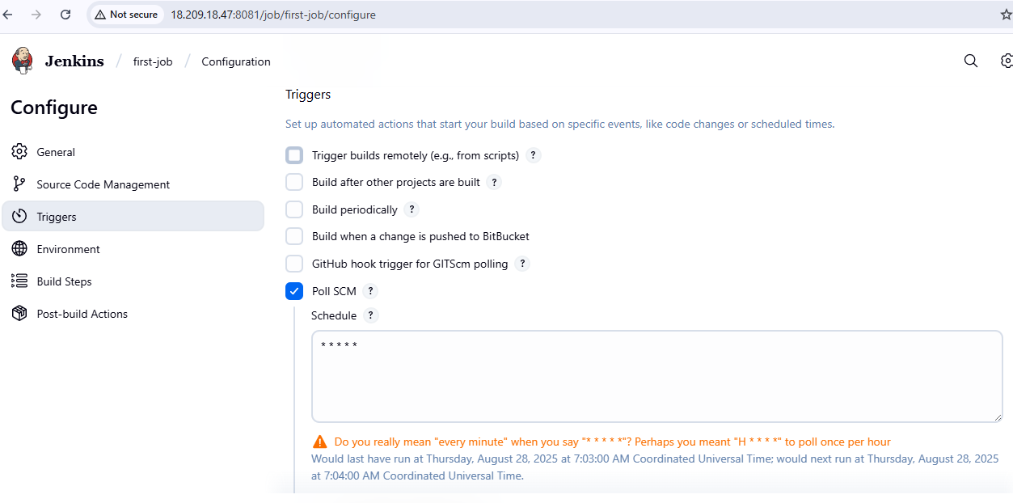

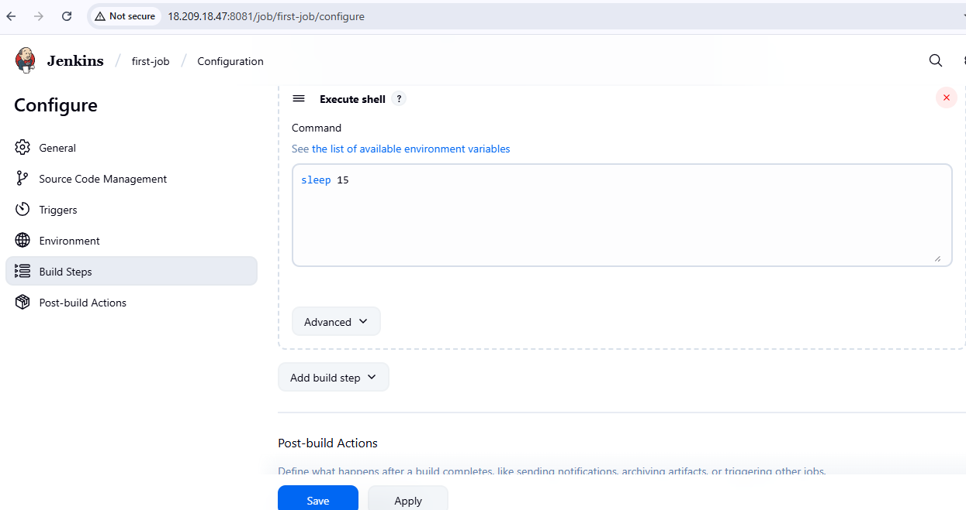

Go to **Github** to **commit changes**



Then we see the **job trigger** in **Jenkins**

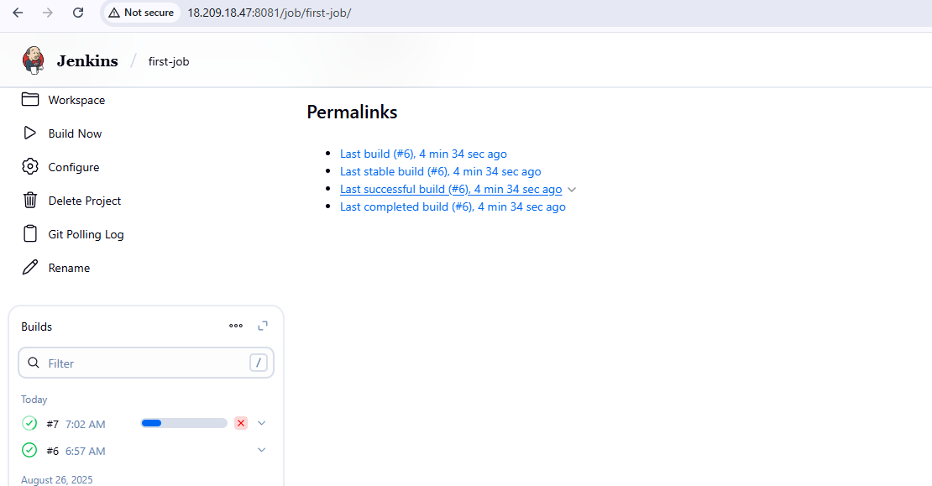

**ii)To configure build periodical options in Jenkins job.**

**Go to Jenkins →** select your job(**first-job) →** add **github u**r**l** in **git repository →** select **Build periodically** in **Triggers →** To keep **sleep 15** in **Execute shell →** click **save**

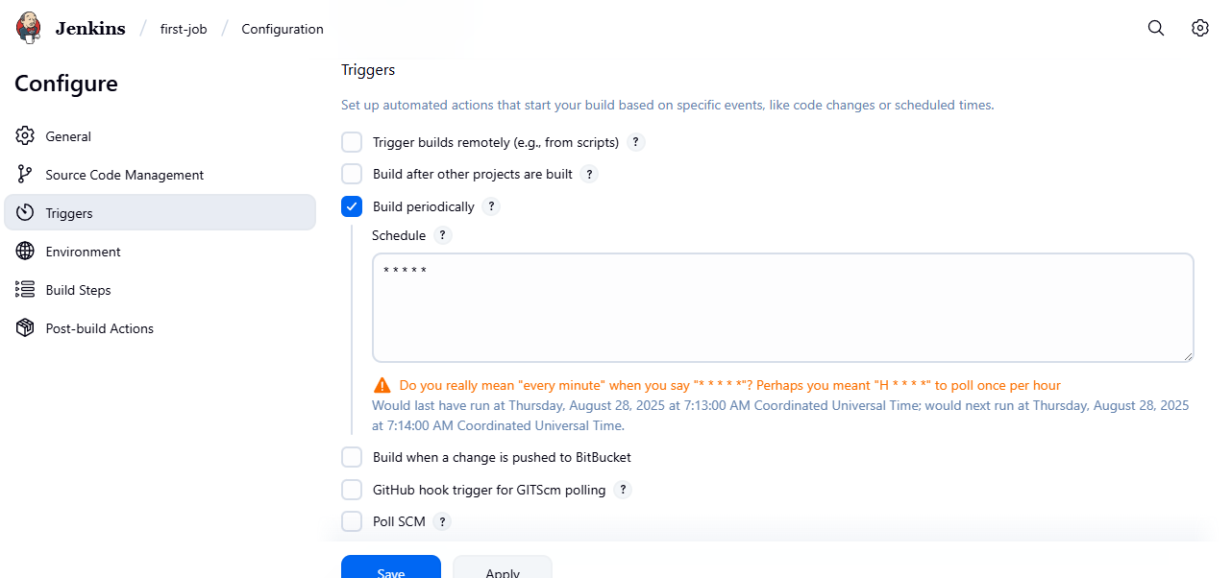

Then we can see **it triggers continously without commit changes**

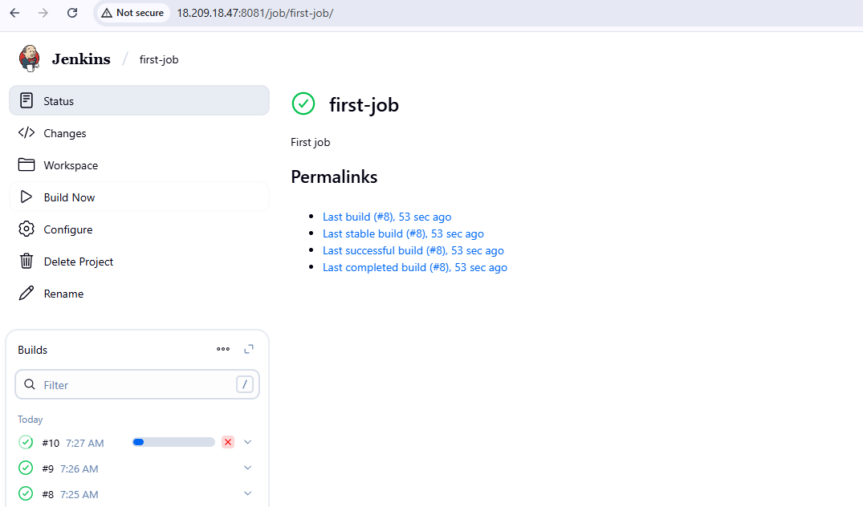

**You can check files in our EC2 jenkins file.**

**cd /var/lib/jenkins/workspace**



**4) Take backup of Jenkins server by using bash script.**

Create a script

**vi jenkins-backup.bash**

|  |
| --- |
| **#!/bin/bash**  **BACKUP_DIR="/backup/jenkins"**  **JENKINS_HOME="/var/lib/jenkins"**  **DATE=$(date +%F-%H-%M)**  **mkdir -p $BACKUP_DIR**  **tar -czvf $BACKUP_DIR/jenkins-backup-$DATE.tar.gz $JENKINS_HOME**  **echo "Backup completed: $BACKUP_DIR/jenkins-backup-$DATE.tar.gz"** |

give permission

**chmod 700 backup.bash**

**./backup.bash**

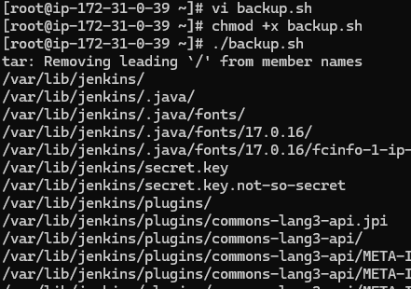

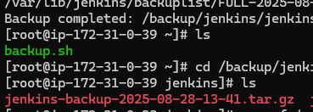

**5) Take backup of Jenkins using rethin backup plugin.**

Install **thinbackup** from **plugin** in **jenkins**

Go to **Jenkins --> Manage Jenkins --> Plugin**

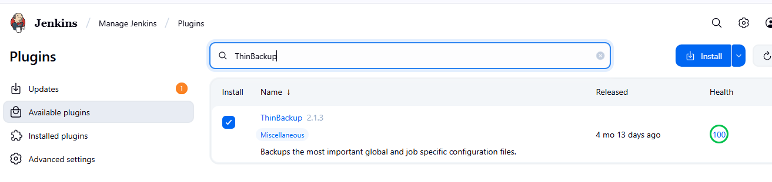

In **tools and actions** you get **Thinbackup**

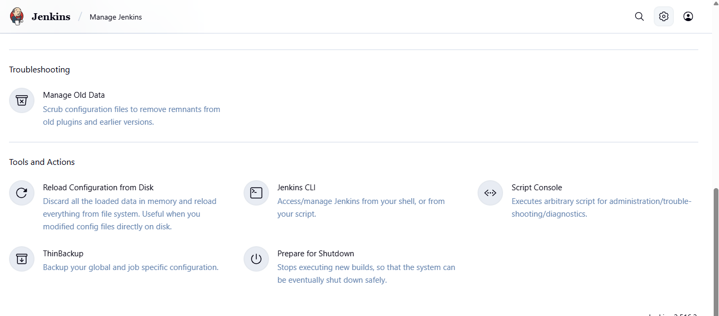

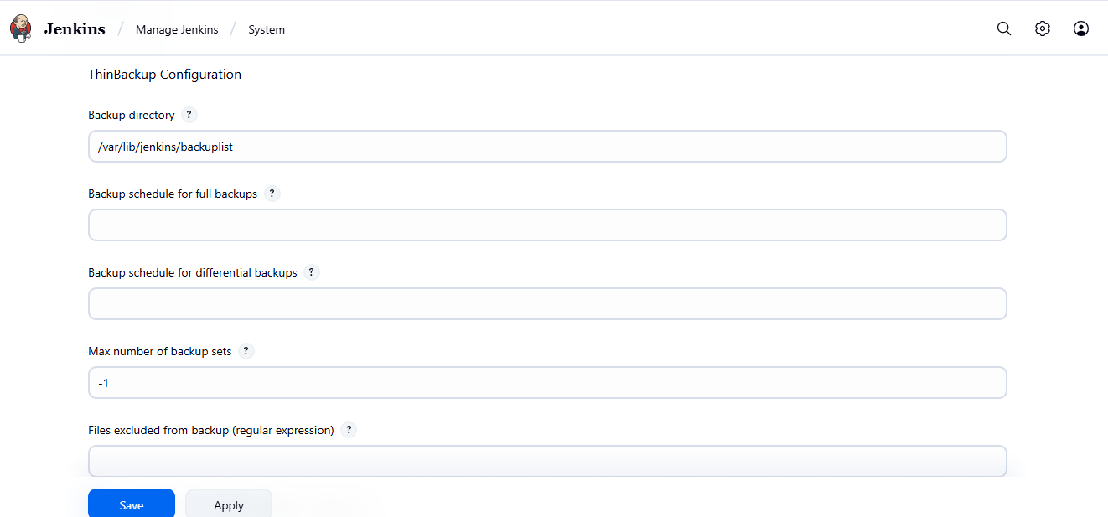

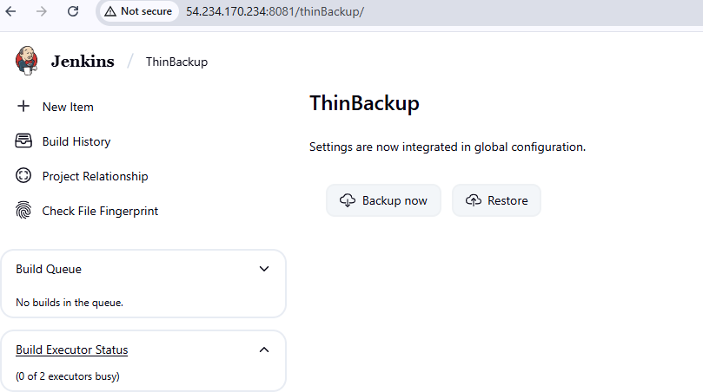

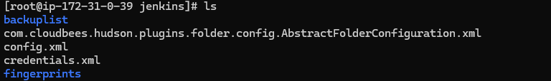

**6) Setup a new Jenkins server and dump the backup taken in task4.**

**Launch a new EC2 instance(backup-jenkins)**

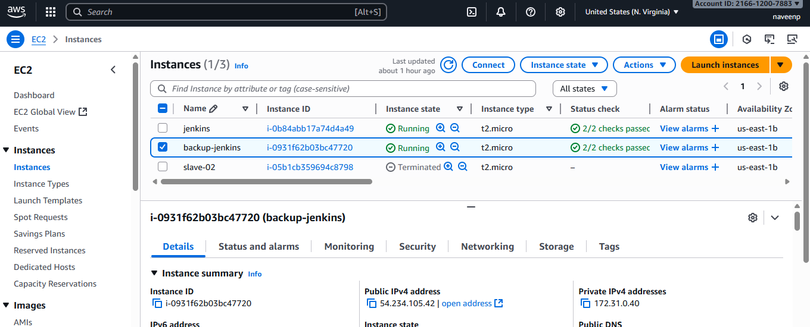

#Install Java (required for Jenkins)

**sudo dnf install -y java-17-amazon-corretto**

#Add Jenkins Repository

****sudo wget -O /etc/yum.repos.d/jenkins.repo https://pkg.jenkins.io/redhat-stable/jenkins.repo****

****sudo rpm --import** <https://pkg.jenkins.io/redhat-stable/jenkins.io-2023.key>**

#Install Jenkins

****sudo yum install jenkins –y****

****systemctl enable jenkins****

****systemctl start Jenkins****

****systemctl status jenkins****

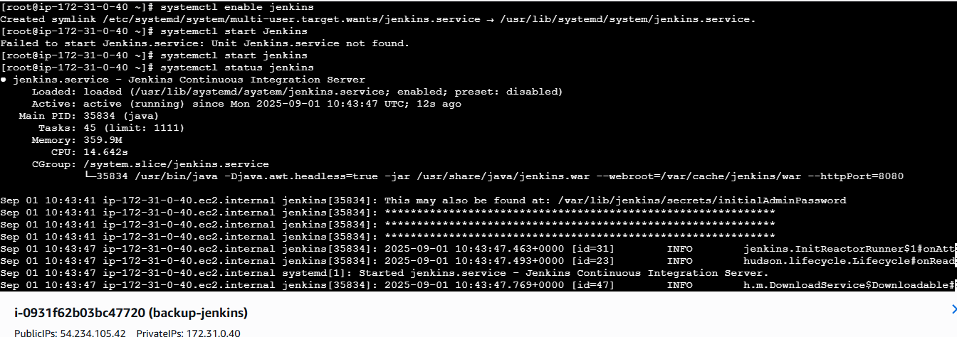

**Step 2:** Copy Your Backup to New Server

Login into your old main server you took backup

Create an test.pem file where you copy your pem key of new-server and and paste in the oldserver

**scp -i test.pem backup.tar [ec2-user@44.203.148.202:/tmp](mailto:ec2-user@44.203.148.202:/tmp/)**

**test.pem**  - is your new server pem key

**backup.tar** - backup file

**[ec2-user@54.234.105.42](mailto:ec2-user@44.203.148.202)** - public ip of new server

**/tmp**  – is the location in new server where you send your backup tar file

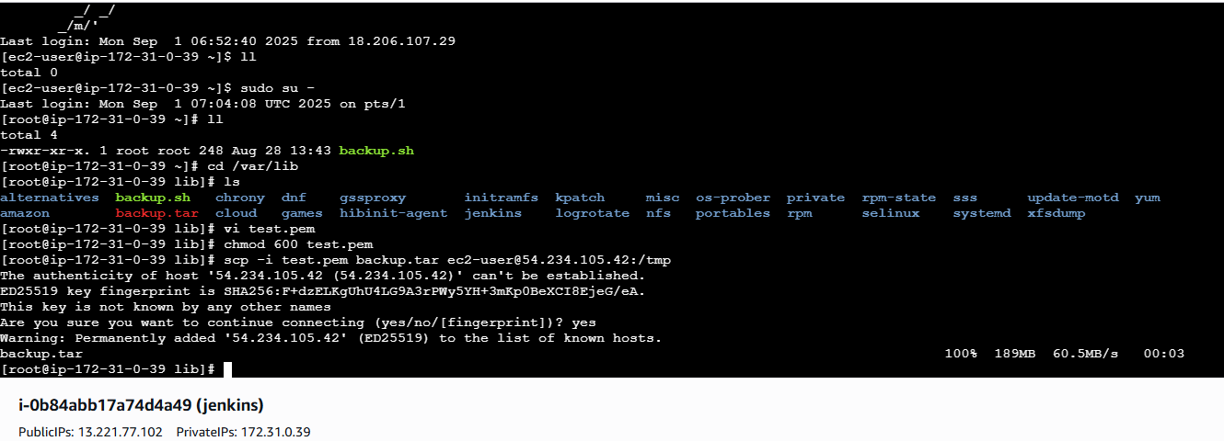

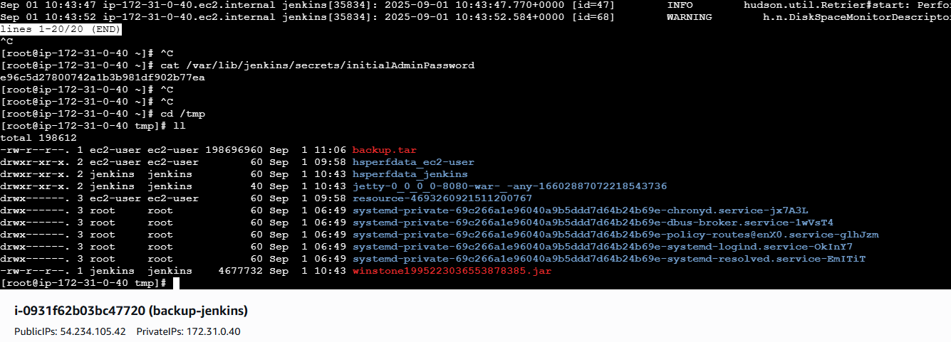

**Step 3:** Login in to new server and check the file in /tmp

Copy the file from tmp to /var/lib

**cp backup.tar /var/lib**

**tar xvf backup.tar**

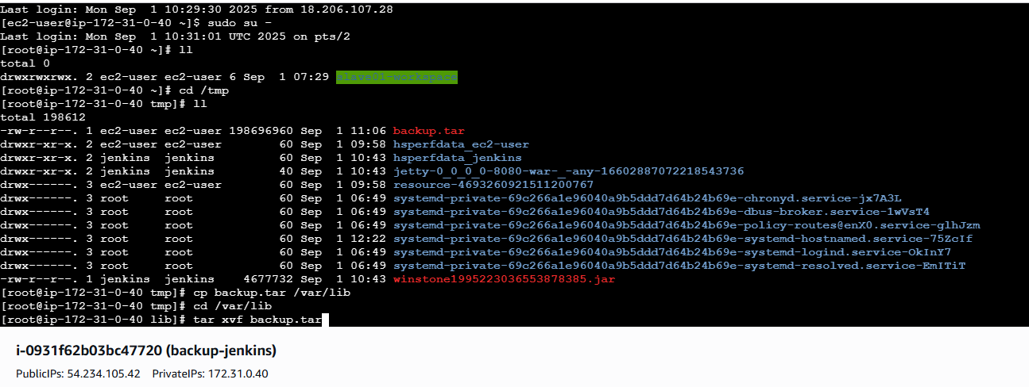

**sudo systemctl start jenkins**

**sudo systemctl status Jenkins**

Verify in browser

http://<EC2-Public-IP>:8080

new server by default running on port no-: 8080

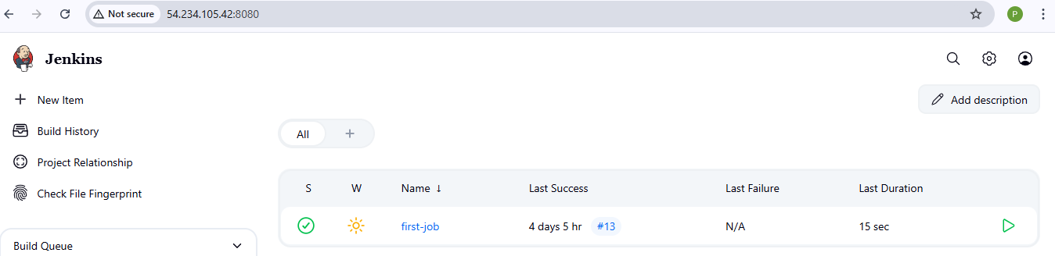

**Old server running on port –no. :- 8081**

